SysTick
Technical Report

Author: Miroslav Denkov
Student Number: 524298
Date:9/3/2025

Introduction

In this assignment the task is to learn about SysTick. SysTick is a 24-bit down-counter built into the Arm’s Cortex-M4 core of the STM32 Nucleo F303RE MCU. It provides a precise timing source and is commonly used for delays, periodic interrupts, and RTOS task switching.

Connection Design

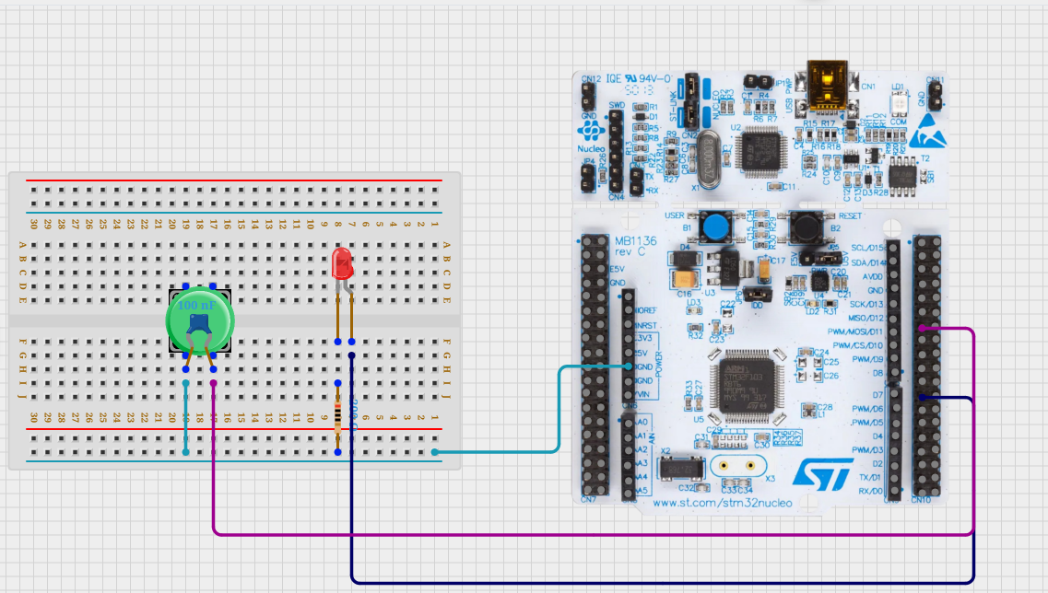
This design uses two buttons (PA6 and USER aka PC13), and a LED connected to PA8. The PA6 button is debounced using a 100nf capacitor.

Code Design

The software works the following way:
The mcu checks two buttons for activity. If PA6 is pressed, we blink the LED in a pattern to display SOS in morse code (. . . - - - . . .). If PC13 is pressed, we print the data from the GetMillis() funtion, which counts how many milliseconds the cpu has been running

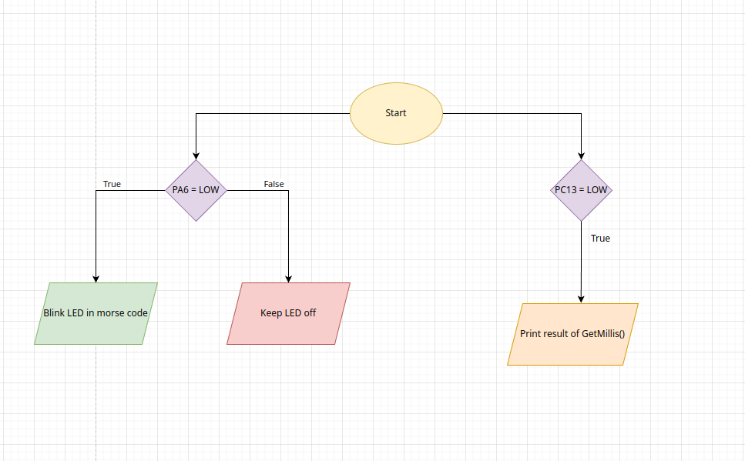

Test results

Console output of GetMillis():

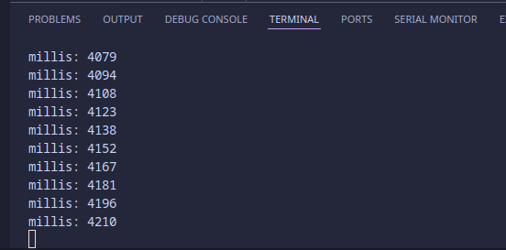

Console output of MorseCode running:



Conclusion/reflection

This assignment taught me a lot about SysTick and also was an extra practice on GPIO and Interrupts. I have gained a better understanding on how the MCU clock works and the inner workings behind the delay and millis functions I have used on Arduino in the past. For the future I want to experiment with the CubeIDE, since I do not want to restict myself to VS code .

